**Variables in JavaScript**

Variables in JavaScript are statements used to store data in specific memory locations.

Variables in JS are divided into 3 types:

1. [var](var%20keyword.docx)
2. [let](let%20keyword.docx)
3. [const](Constants.docx)

**Creating variables**

To create any variable you need to do two main processes, these two process are **declaration** and **initialization** processes.

1. **Declaration process**: it’s a process of determine [identifier](Identifiers.docx) to the variable.

This process consists of two members: **variable** **keyword** & **nameOfVariable**. “**Undefined**” is the default value of declaration process.

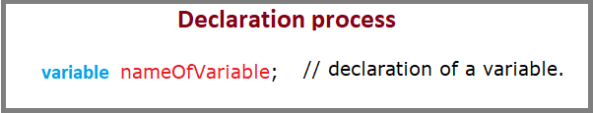

1. **Initialization process**: it’s a process of determine [data](Data%20Type.docx) (value) to the variable.

This process also consists of three members: **nameOfVariable** **=** **data type**

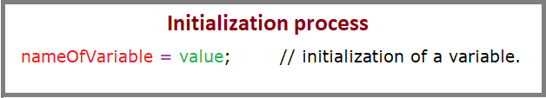

**Note:** if you make declaration process without initialization process; then this variable will take the default data type “**undefined**”.

You can create two steps together at once:

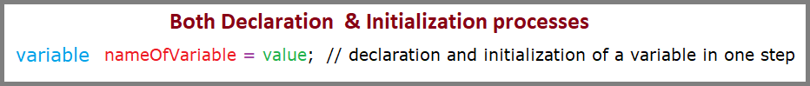

**Different ways on declaration & initialization processes:**

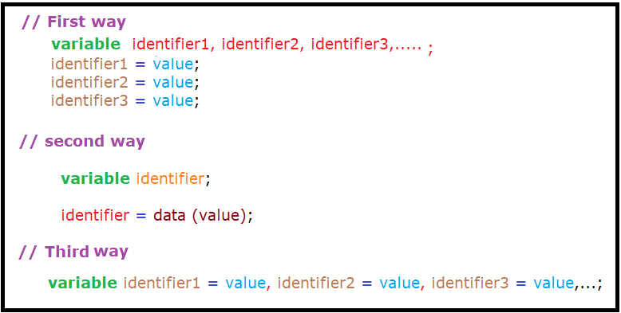

**Important note:** In case of const variable only the third way was effective. First and second ways will give errors.

**How variable store data**

Before knowing how variables stored data we need to know the composition of this virtual computer memory.

Computer memory consist of huge number of preserved locations called memory locations all have no stored data “**undefined**”

|  |  |  |  |
| --- | --- | --- | --- |
| **Computer memory** | | | |
| **Identifier (pointer)** | **dot** | **Memory location address** | **Stored data** |
|  | **.** | **FFFE** | **undefined** |
| **.** | **EEEE** |
| **.** | **05E0** |
|  |  | **9EF2** | **undefined** |
|  |  | **0X1001000** | **undefined** |
|  |  | **0X1001003** | **undefined** |
|  |  | **0X1001032** | **undefined** |
|  |  | **7676524663** | **Undefined** |
|  |  | **2632476788** | **Undefined** |
|  | **.** | **0X13001000** | **Undefined** |
| **.** | **0X10011000** |
|  |  | **8432** | **Undefined** |
|  | **.** | **0X1231000** | **undefined** |
| **.** | **0X1431000** |
| **.** | **12X121300** |

**Where:**

1. **Identifier** is a distinctive name used to referee to a specific memory location instead of its **complexity** address.
2. **Dot** is an operator used to referee to a specific value in case of reference stored data (dot is used only with **reference** data type).
3. **Memory location address** is a complex address referee to a specific memory location inside the virtual computer memory.
4. **Stored data** referee to data that you pass to the identifier to stored it and call it again when needed. (undefined is the default value)

After making declaration process a specific memory location was named as the name of identifier and will be used to store data. As you notice that memory location may be only one memory location or several memory location pointed by a pointer. If the storing data type is string, number, Boolean “primitive data type” then there is only one memory location was preserved for this identifier because primitive data type contain only one value; while if this data is Array, object, null “reference data type” then there is several memory locations were preserved for this identifier, pointed by pointer because reference data type contain several values.